Student
Institution
Course
Date

This week we learned about marketing analytics. We learned that, the key decision tool for the marketers is customer relationship management, which involves systematic attracting of the consumers preferences and behaviors over time in order to tailor the personalized value propositions. Through that, the organization is going to get ‘up close and personal’ and enact their customer orientations. The CRM also facilitates one to one marketing which includes several steps including the identification and getting to know them in as much detail as possible. Secondly, one should be able to differentiate the customers in terms of their needs and their value to the firm. Thirdly, the organization should interact with the customers and find ways that they can improve their cost efficiency as well as effectiveness of the interaction. Fourthly, one need to customize some of the aspects of goods and services that are offered to the costumers.
The chart below shows the Customer related Metrics
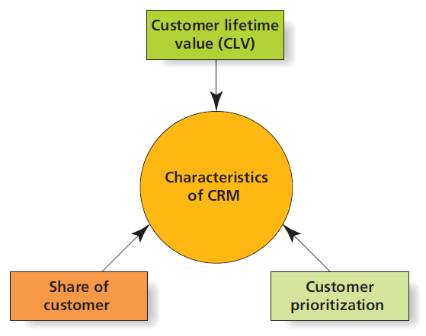
Share of the customer is also very important in an organization. In this week lessons, we learned that it’s easier and less expensive to keep the current customer than to acquire a new one. This is the reason as to why many firms concentrate to increase the share of customers instead of increasing the share of the market. The share of the customers of the customers is the number of customer’s purchases over a time which allows the company to grow over time compared to acquiring new customers.
We also learned about customer Equity and lifetime value, in which we were taught that lifetime value of the customer is the amount of the profit that the firm makes on the client while customer equity is the financial value of the customer relationship which takes into account the monetary investments to acquire and maintain relationships. In order to succeed in business, prioritization of the customer is also imperative. It’s clear that it’s not all the customers that are equal in other terms other than profitability. CRM is important in identifying the most important customers as well as customizing communications and special offers. The transformation of customers into corporate asset was also a very interesting topic. We were taught that we need CRM to leverage the database technologies to customize the customers interactions based on the customer prioritization, lifetime value and customer equity and the share of the customer.
In the Big Data, we defined that as a popular term that is used to describe the exponential growth of both structured and unstructured data. Example of structured data include date, time, census data and Facebook likes while unstructured data include the body of emails, tweets, Facebook status and video transcripts among others. There are insights that are obtained from Big Data and they can help in providing the competitive advantage in three main ways which are spotting new opportunities, changing the insights to better products and offering timely information more efficiently and effectively.
These are some of the sources of the Big Data for the marketers
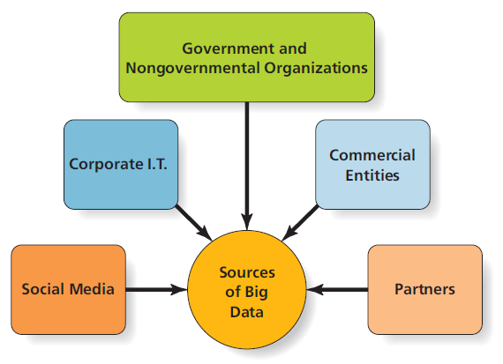
Data mining process is also a very paramount topic that we learned. Many firms don’t know what to do with the biggest data. Data mining is the process in which the data analysts sifts through the Big Data in order to identity the unique patterns of the behavior. The ethical and sustainable decisions in real world is a very important topic. Software algorithms are unavoidable because every sector is in need of them in one way or the other. Social media companies chooses the stories that they need to appear in their trending topics.
Marketing analytic can be defined as technologies and processes that enables marketers to collect, measure, analyze and evaluate effectiveness of the marketing. Predictive analytics on the other hand can be defined as the people who use large quantities of data to predict the future outcomes. Some of the value of digital marketing investments that we learned include cost-per click, cost-per-impression, search engine optimization and comparing average cost per customer transaction. There are also key marketing metrics which include click-through rate, conversion rate, cost per order, and margin of sales and churn rate.

Work Cited
Solomon, Michael R., Greg Marshall and Elnora W. Stuart, Upper Saddle River, New Jersey: Prentice Hall, 2018.

